**The Battle of Neighborhoods**

Introduction

Toronto is an international centre for business and finance. Generally considered the financial capital of Canada, Toronto has a high concentration of banks and brokerage firms on Bay Street, in the Financial District.

The city is an important centre for the media, publishing, telecommunication, information technology and film production industries.

Although much of the region's manufacturing activities take place outside the city limits, Toronto continues to be a wholesale and distribution point for the industrial sector.

The city's population grew by 4% (96,073 residents) between 1996 and 2001, 1% (21,787 residents) between 2001 and 2006, 4.3% (111,779 residents) between 2006 and 2011, and 4.5% (116,511) between 2011 and 2016.

Based on the information above, Moonbucks, an multinational [coffee](https://en.wikipedia.org/wiki/Coffee) company and [coffeehouse chain](https://en.wikipedia.org/wiki/List_of_coffeehouse_chains), decides to expand their business to Toronto.

Business plan

Moonbucks Co. is an multinational [coffee](https://en.wikipedia.org/wiki/Coffee) company and [coffeehouse chain](https://en.wikipedia.org/wiki/List_of_coffeehouse_chains). It has thousands location worldwide at the end of 2018.

To compete with Starbucks, it provides high perfect services as well as high quality coffee, initially distinguishing itself from other coffee-serving venues in the US by taste, quality, and customer experience while popularizing darkly roasted coffee.

Moonbucks desires to choose a location with a density traffic but median cost of coffeeshop rental, to test their business first, then expands rapidly to dominate the market.

This type of problem has many valuable lessons that apply to many different types of industry. A lot of fast food restaurants, such as KFC, have been doing something very similar in their location analysis. Any business that is looking for a new location would find this type of analysis very handy in determining their future building site.

Data

We will need geo-locational information about the Toronto in all boroughs and the neighborhoods in those boroughs. We will first find all boroughs in Toronto by their corresponding Postal Codes. Then we will need data about different venues in different boroughs to seek the top 10 venues on hot. In order to gain the desired information, we will use Foursquare locational information. As basic information, we can obtain its precise latitude and longitude. But we are also looking for advanced information such as why this venue is a popular one in its category or what the rental price of the coffeehouse is.

**Data Sources**

Demographic Data of Toronto come from [Wikipedia](https://en.wikipedia.org/wiki/Demographics_of_Toronto) and [Toronto Transit Blog](http://www.torontotransitblog.com/430185149/4846960/posting/)

Postal Code and Borough of Toronto come from [Wikipedia](https://en.wikipedia.org/wiki/List_of_postal_codes_of_Canada:_M).

All venue’s data come from API of [Foursuqare.com](https://foursquare.com/).

**P.S.** In further researching, we still need to acquire more detailed demographic data of Toronto, such as the population density/traffic of each borough, and also the shop rental of each borough, in order to estimate the revenue and cost.

Methodology

A number of Python libraries have been used in this project to perform data analysis & visualization. Below are some of them:

1. **Pandas** provide high-level data structures and a vast variety of tools for analysis. The data once sorted and filtered is put into Dataframes to perform further analysis and visualizations.

2. **Matplotlib** is the most popular data visualization library in Python. It is used to create figures and plots.

3. Geocoding refers to the conversion of addresses into coordinates and, vice versa (reverse geocoding). **Geopy** is an excellent Python library for (among others) geocoding and reverse geocoding that supports many APIs. In this project, the **Nominatim API**, which is based on OpenStreetMap (OSM) data, is necessary.

4. **Folium** is a powerful data visualization library in Python that was built primarily to visualize geospatial data. With Folium, one can create a map of any location in the world if its latitude and longitude values are known. As these maps were interactive in nature, it was quite handy to zoom in and out locations once rendered.

The first step in determining the solution to the given problem of what neighborhood should the client open a coffeehouse is to import our needed libraries, data about Toronto neighborhoods, and then clean the data. Here is an output of our cleaned data that contains information related to the neighborhoods that are found within the Toronto:

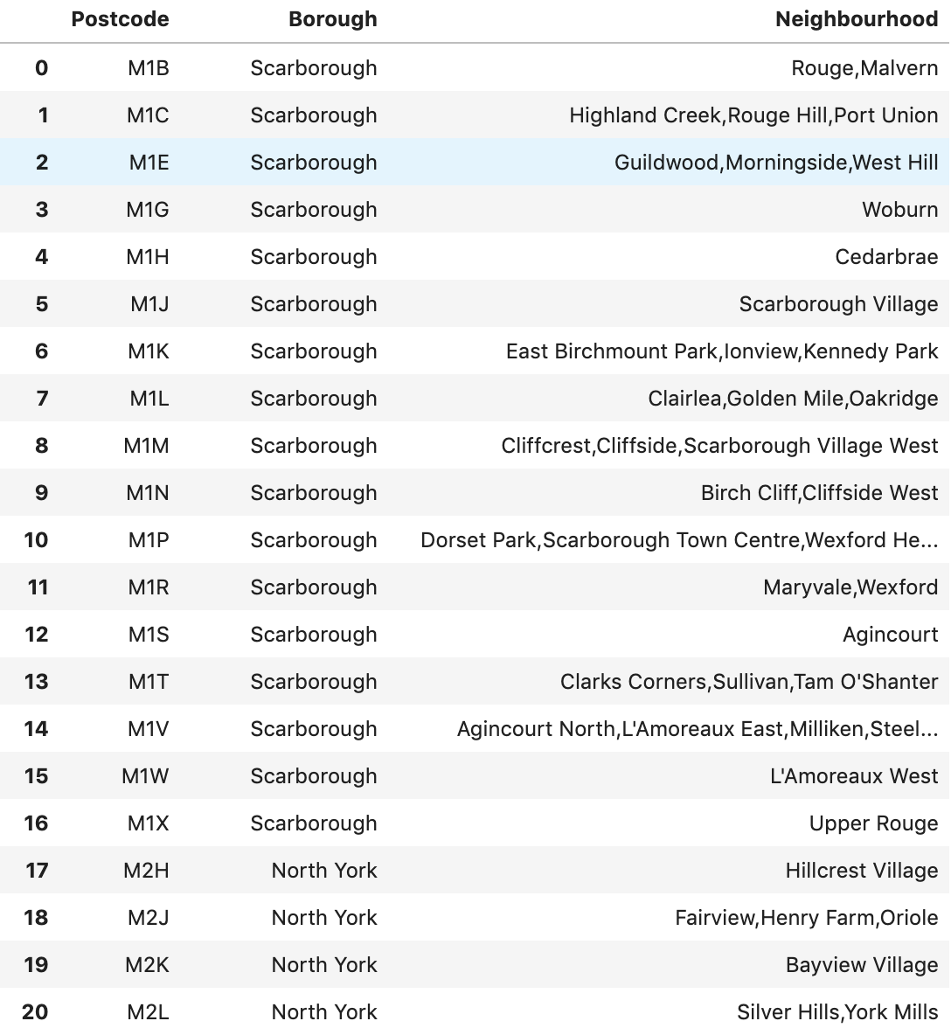

Now that we have the neighborhood information, we will move on to getting the geo-spacial (Latitude and Longitude) information for the given neighborhoods:

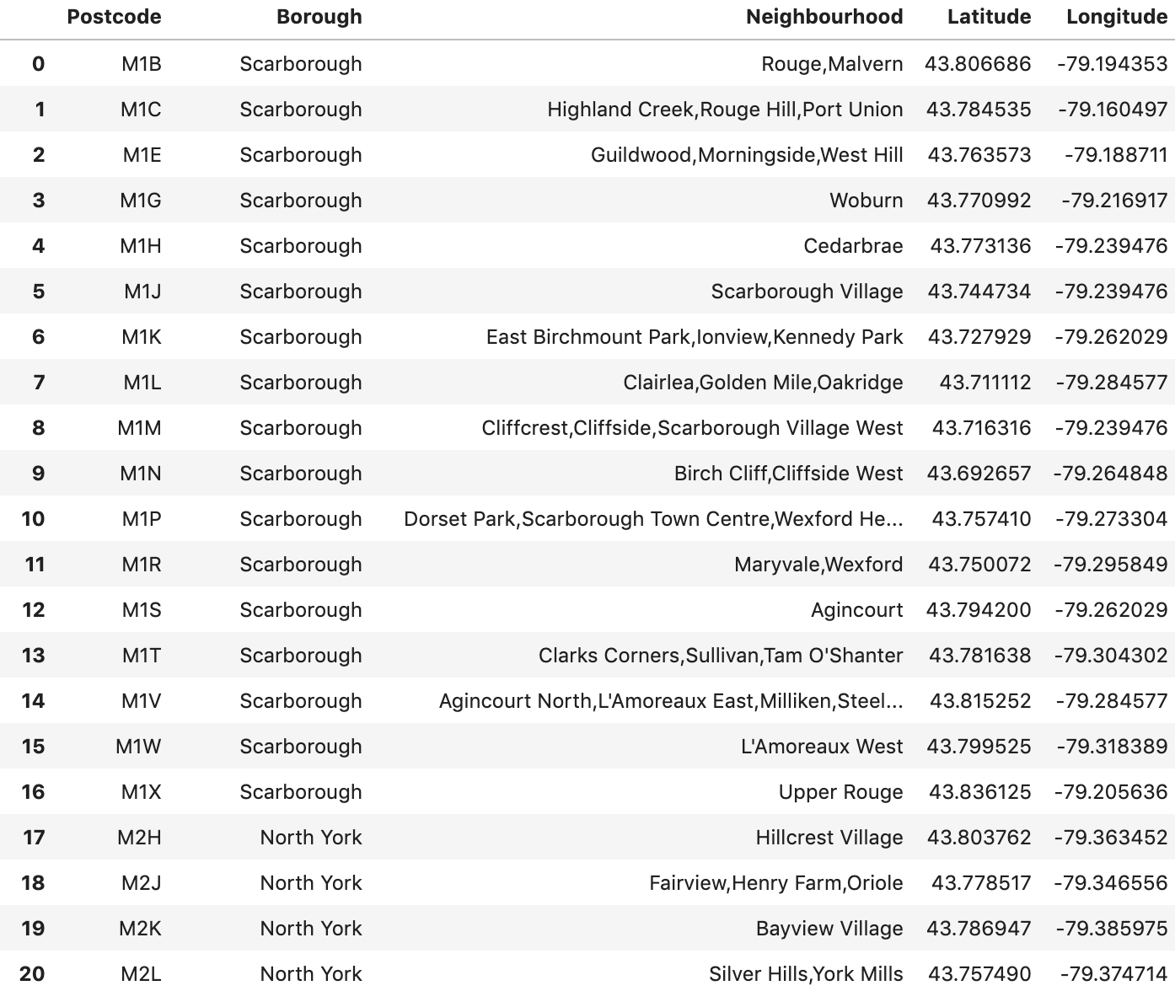

Next, we will generate a folium map to show the neighborhoods within Toronto:

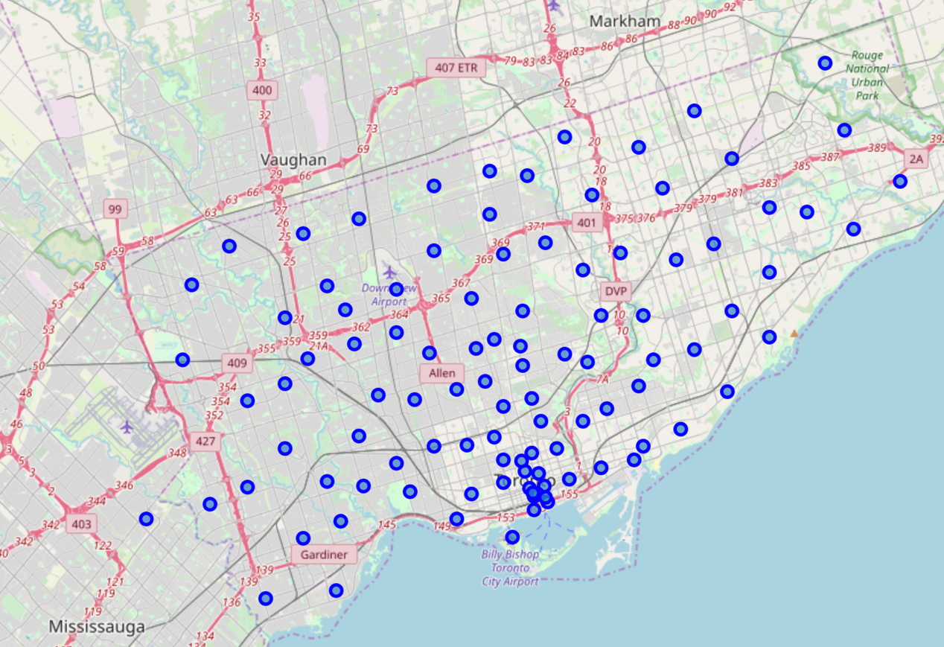

Our next step is to use the FourSquare API to determine what types of business establishments are in each neighborhood. This will help determine out potential client and we will determine the traffic of our coffeehouse. By doing this we can start to collect the most popular venues in each borough as follows(e.g.):

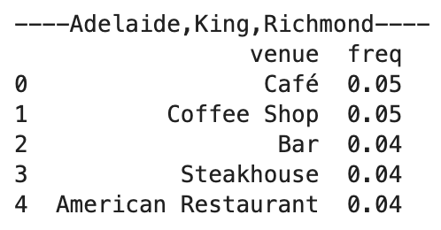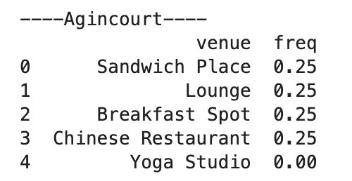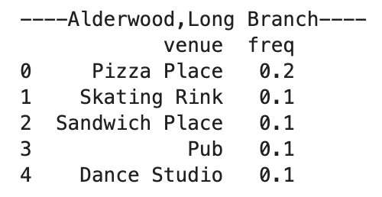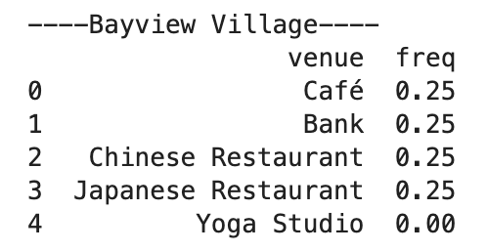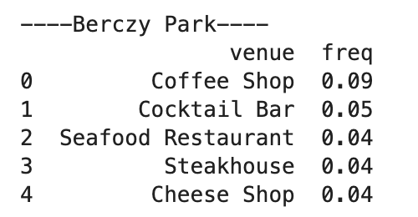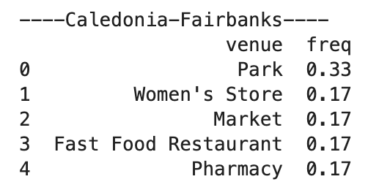

Our next step will be to use K-Clustering to determine, more in depth, where the best potential site will be located:

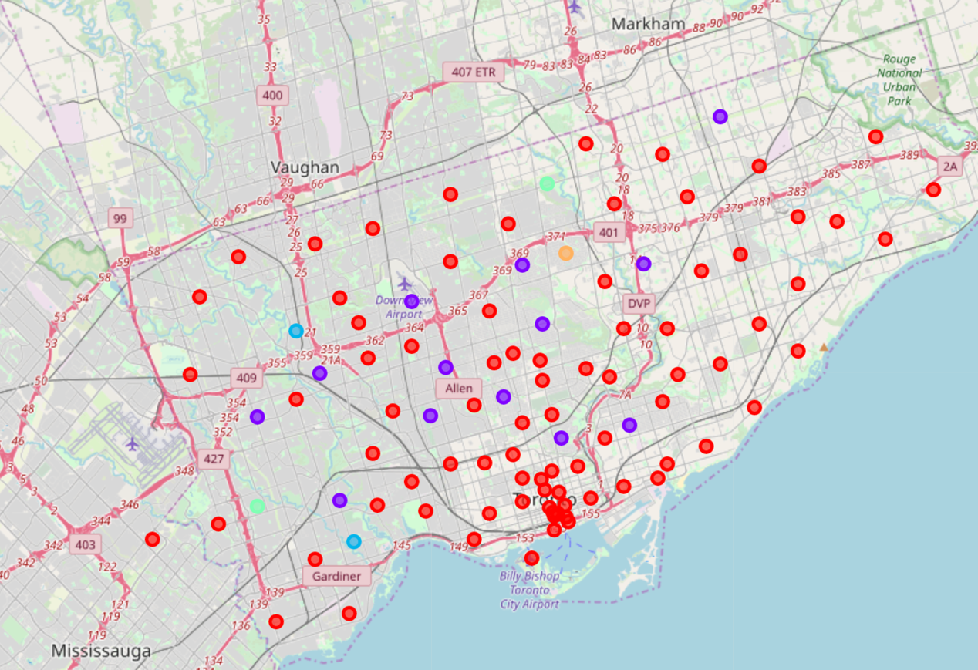

The clustering shows in red indicates that there are a lot of boroughs located in Toronto are high traffic place for restaurant/coffeehouse. But the wide range of data is not precise enough for us to choose the location. So we refine the data by clustering again and see what happens:

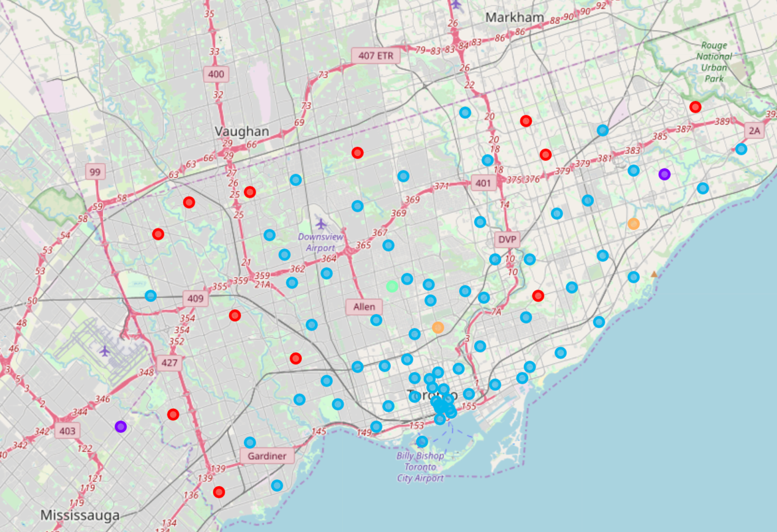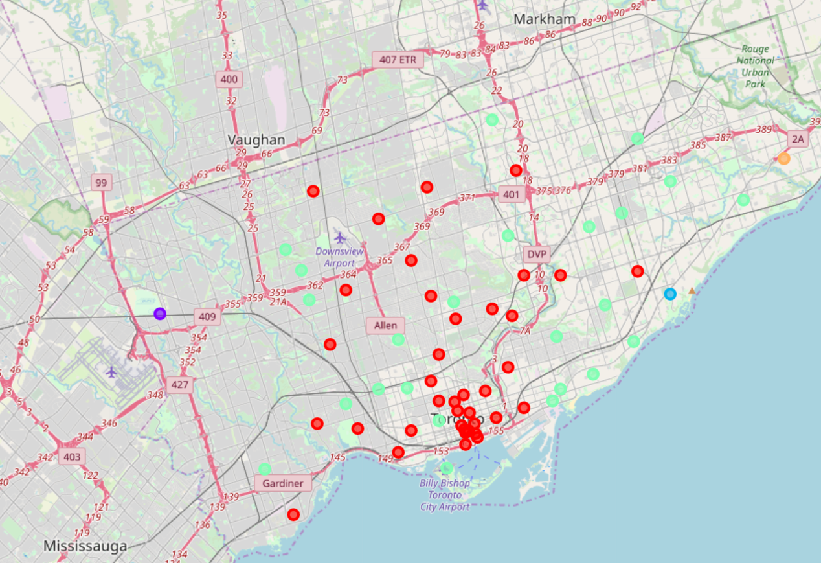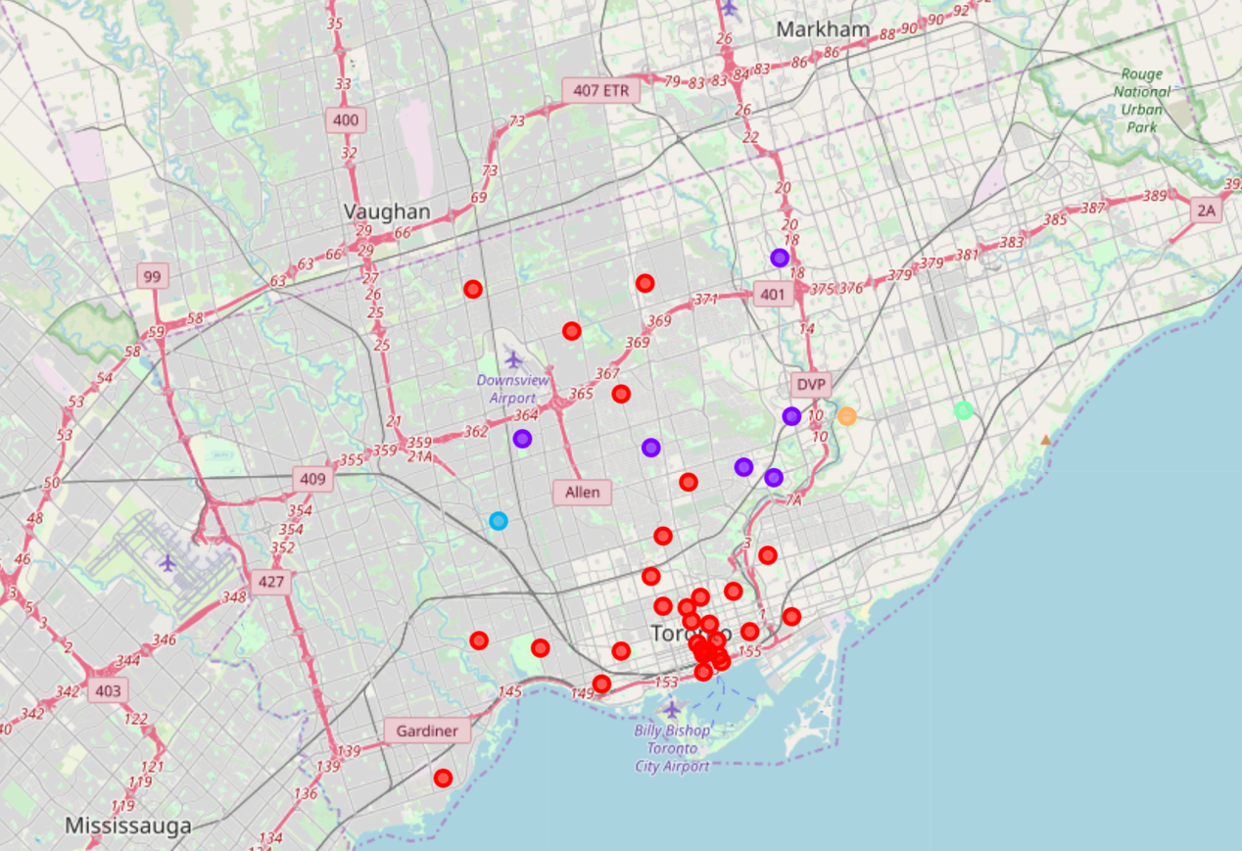

To refine the data by clustering 4 more times, we eliminate the data into an acceptable size and the data show that most of the places we can choose are located in the Downtown Toronto, which also has a high rental.

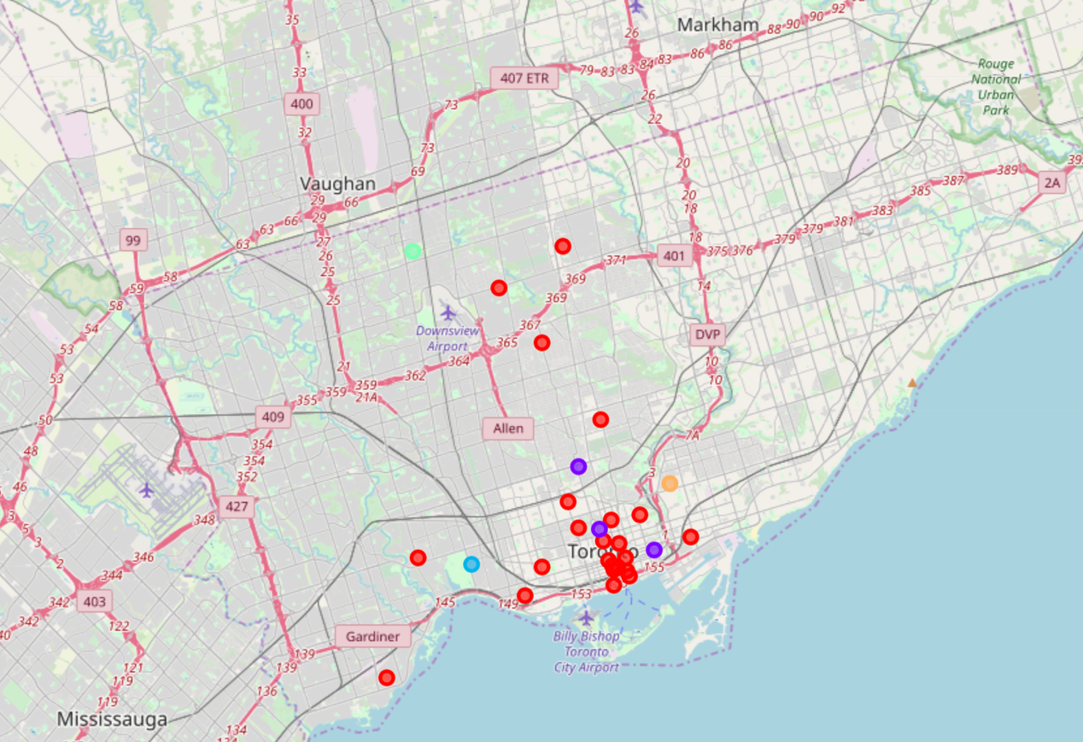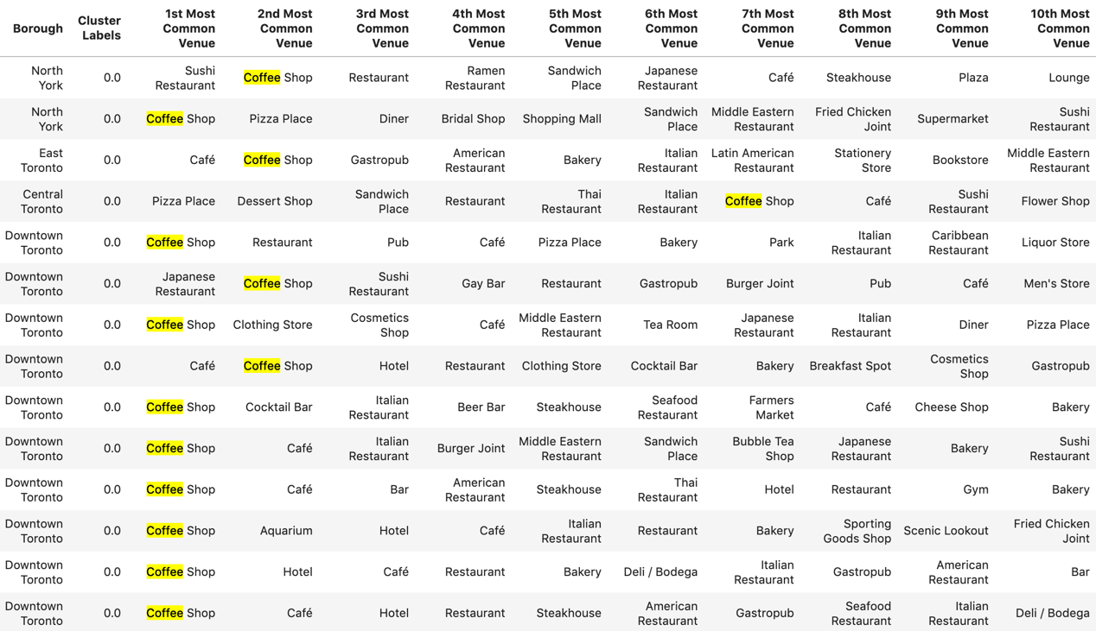

Result

From the result of clustering analysis, we can easily find that the best places for coffeehouse are in Downtown Toronto. Due to the last table, in Downtown Toronto, coffee Shop has a very high ranking in the most common venues. So it’s a reasonable choice to open a coffee shop in Downtown Toronto.

Discussion

Is it true to open a coffee shop firstly in Downtown Toronto? Since we can get the conclusion that the most common venues in Downtown Toronto are coffee shops, we can also conclude that the coffee shops there are meeting a highly competition. So let’s acquire some other information of Toronto to clarify if opening a coffeehouse in Downtown Toronto firstly is a good choice. Here is the population density of Toronto:

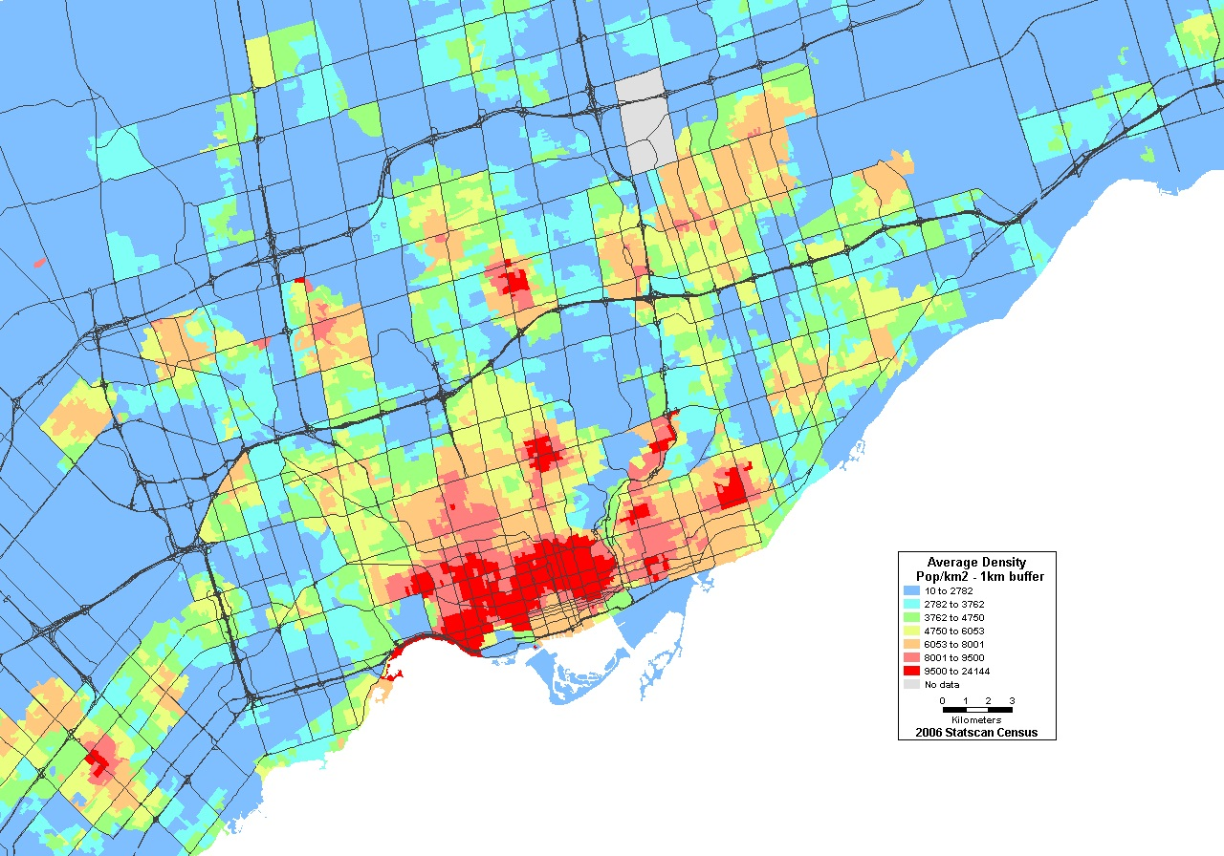

Then we can compare the population density with clustering graph:

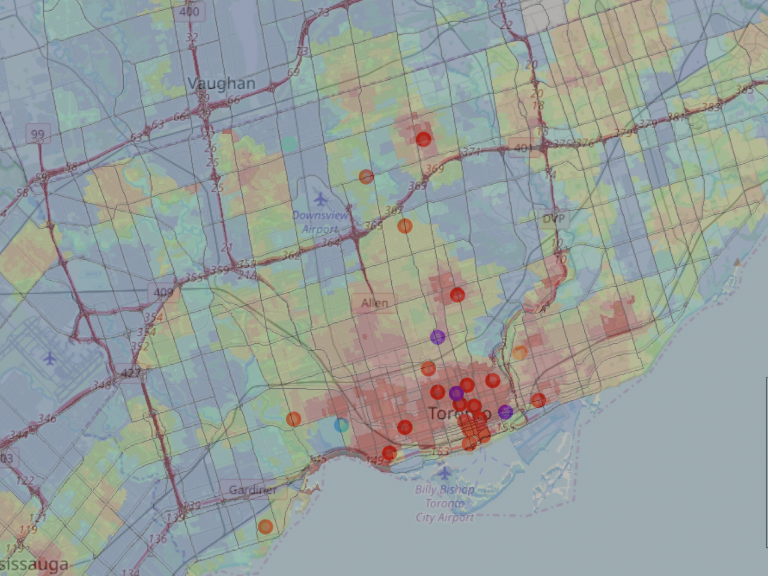

From the graph above, we can see that the best places for coffee shop are high corelated to the population density. Besides Downtown Toronto because of its highly competitiveness and high rental cost, we can choose to open a coffeehouse firstly in neighborhood Willowdale South, borough North York to test our business, then expand our business into Downtown Toronto.

Conclusion

This project was aimed to providing substantial data to support Moonbucks in selecting a neighborhood in Toronto for its investment. However, the final decision will depend on many other factors such as financial inputs, operational agreements & business-related terms and conditions agreed upon by all the stakeholders involved.

After all, the future of Moonbucks in Toronto would depend on how well it is able to sustain with the quality and service in addition to providing a unique experience to coffee lovers.